**Validation of email ID**

**Source code**

**Version 1:**

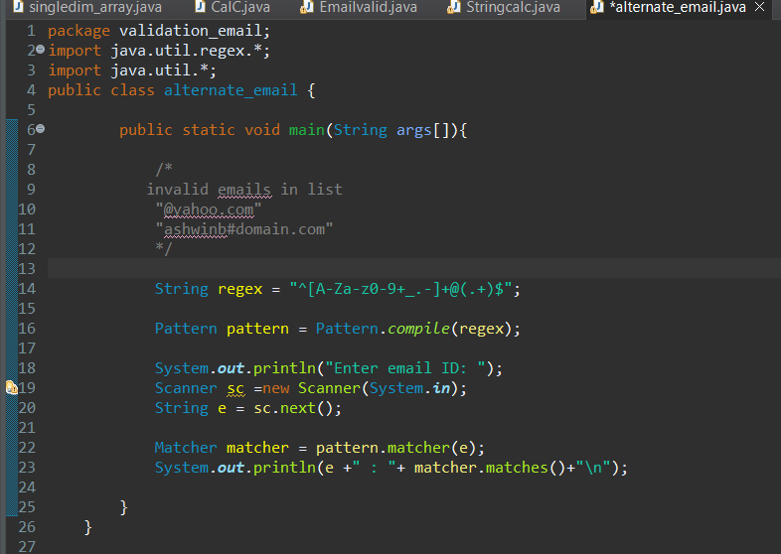

Output:

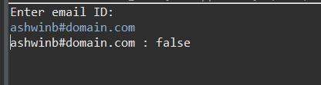

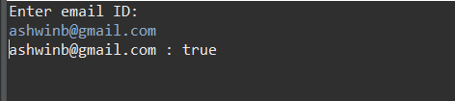

**Version 2:**

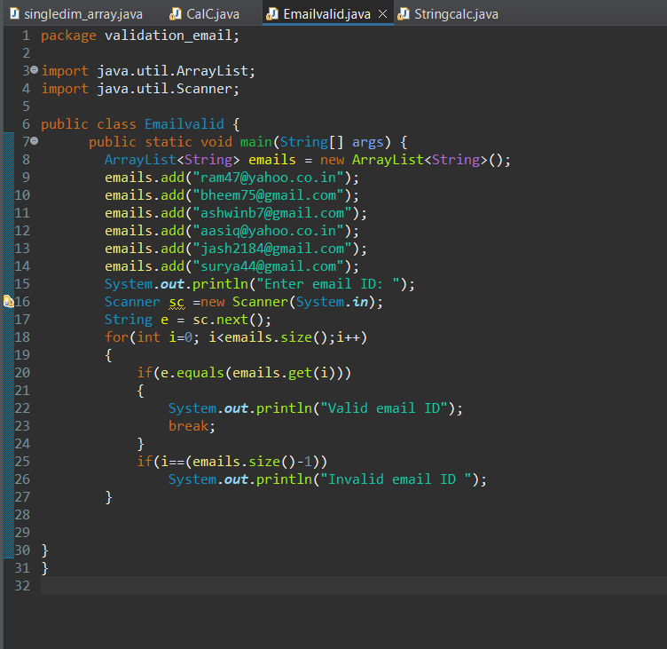

**Output**

